1. Problem Statement: Develop a BankAccount class that implements core banking operations: ○ balanceEnquiry(): Displays the current account balance. ○ withdraw(): Deducts the specified amount from the account balance. ○ deposit(): Adds the specified amount to the account balance. Implement user-defined exceptions: a. LowBalanceException: Thrown when a withdrawal amount exceeds the available balance. b. NegativeNumberException: Thrown when attempting to deposit or withdraw a negative amount. Develop a Java application program that demonstrates these functionalities and properly handles these exceptions using try-catch blocks.

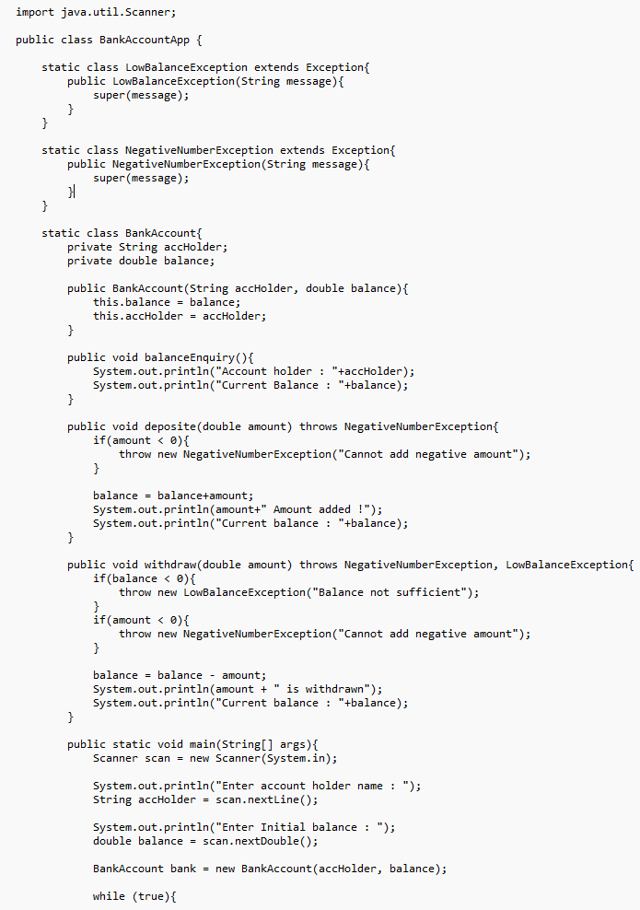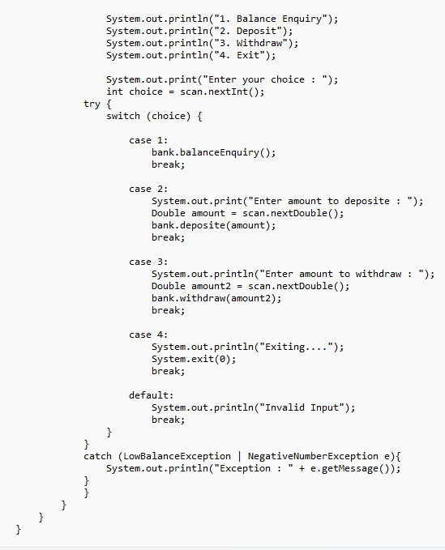

1. Write a Java program with a method that takes an integer as input. If the number is odd, the method should throw a custom exception (OddNumberException). Handle this exception in the main program.

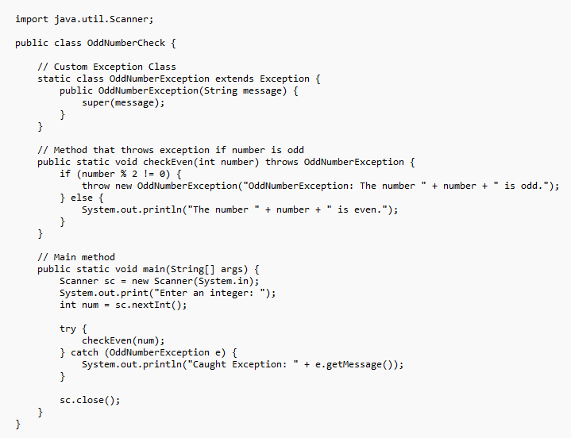

1. Create a package ExceptionHandlingDemo containing classes Calculator and DivisionException. ○ The Calculator class should have a method divide(int a, int b) that performs division. ○ If b is zero, throw a custom exception DivisionException with an appropriate error message. ○ Handle the exception in the main program and display an error message instead of crashing.

